|  |  |  |
| --- | --- | --- |
| RETP logoBASC LOGO | **BULACAN AGRICULTURAL STATE COLLEGE**  **Research, Extension, Production and Development Office**  Pinaod, San Ildefonso, Bulacan 3010 | *Document No.:*  BASC-RO-QSF-11 |
| *Revision No.: 00* |
| *Title:*  **RESEARCH PROJECT ACCOMPLISHMENT REPORT** | *Effectivity Date:08/30/19* |

Month(s) ______ _______ Year _______

1. Institute:
2. Project/Program Title:
3. Project/program Duration:
4. Project/Location:
5. Summary of Accomplishments

1. Summary of Accomplishments
2. Activities Conducted Based on the Approved Work Plan

|  |  |  |  |  |  |
| --- | --- | --- | --- | --- | --- |
| Planned Activities | Activities Conducted | Date Conducted | Outputs | Faculty/Staff Involved | Remarks |
|  |  |  |  |  |  |
|  |  |  |  |  |  |
|  |  |  |  |  |  |
|  |  |  |  |  |  |

1. Other Research Related Activities
2. Non Conformance/Issues and Concerns in the Accomplishment of Research Activity
3. Recommendations to address the non-conformances/issues and challenges/opportunities for improvement for the accomplishment of research.

_________________________________________________________________________________________________________________________________________________________________________________________________________

1. Financial Status (If quarterly report: March/June/Sept./Dec/)

As of , the project has already used up the total amount of __ .

|  |  |  |  |  |
| --- | --- | --- | --- | --- |
| **Date** | **Check no.** | **Payee** | **Particulars** | **Amount** |
|  |  |  |  |  |
|  |  |  |  |  |
|  | | | |  |
|  | | | |  |

**Prepared by:**

_________ Date: _____________

Program Leader

**Reviewed and Endorsed by:**

_________ Date: _____________

Institute Research Coordinator

_________ Date: _____________

Institute Dean

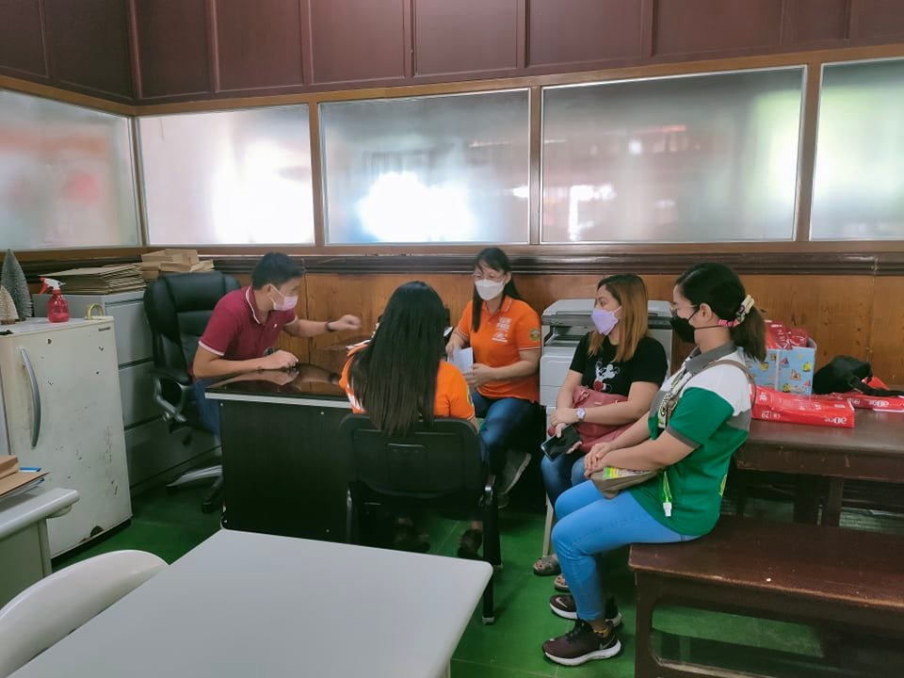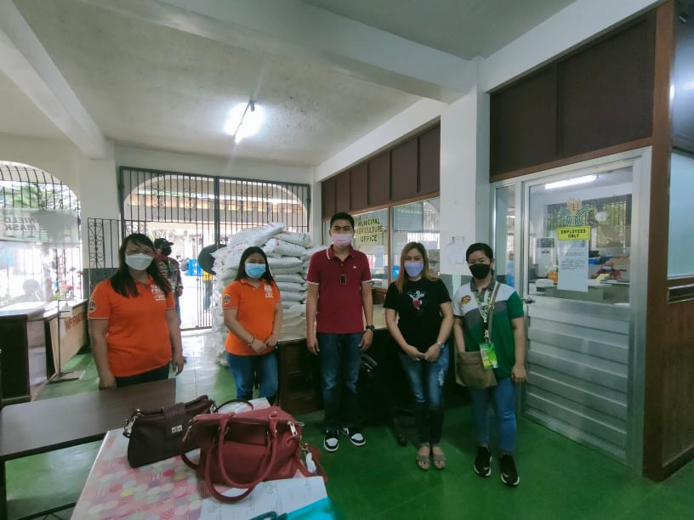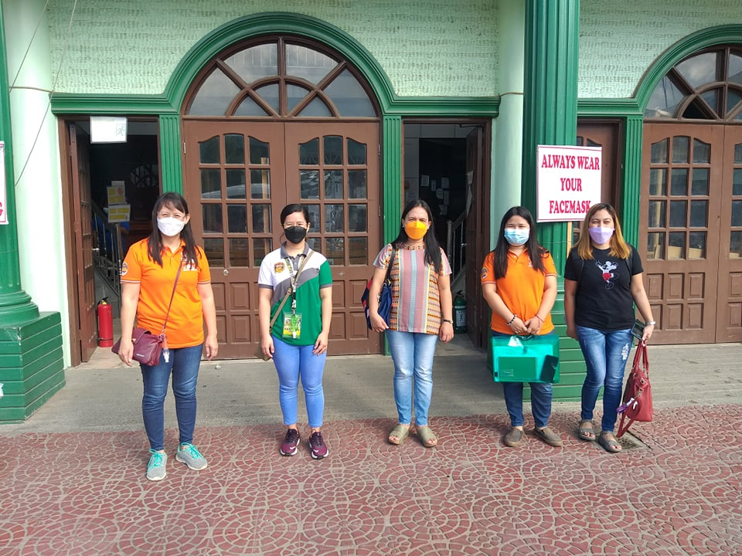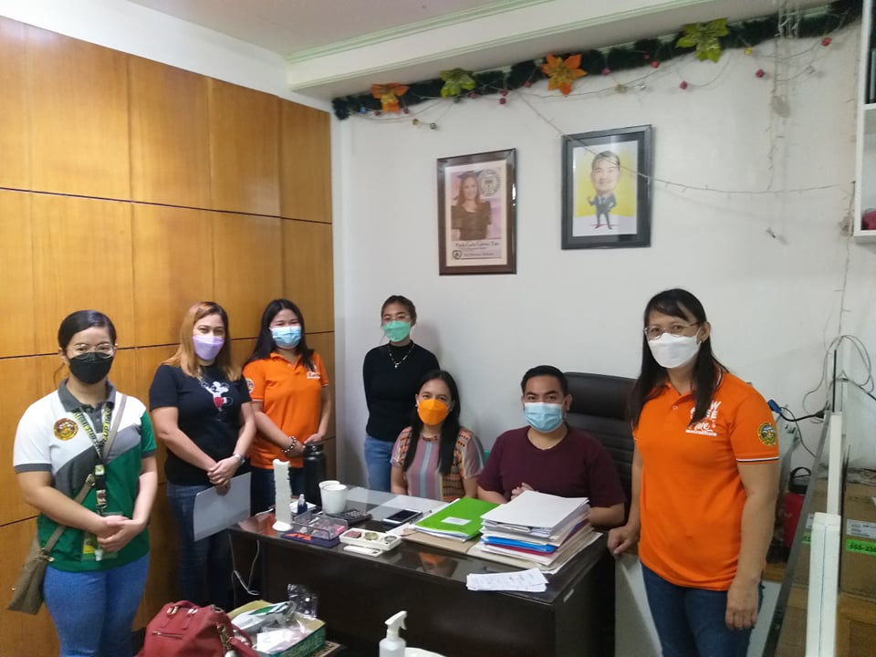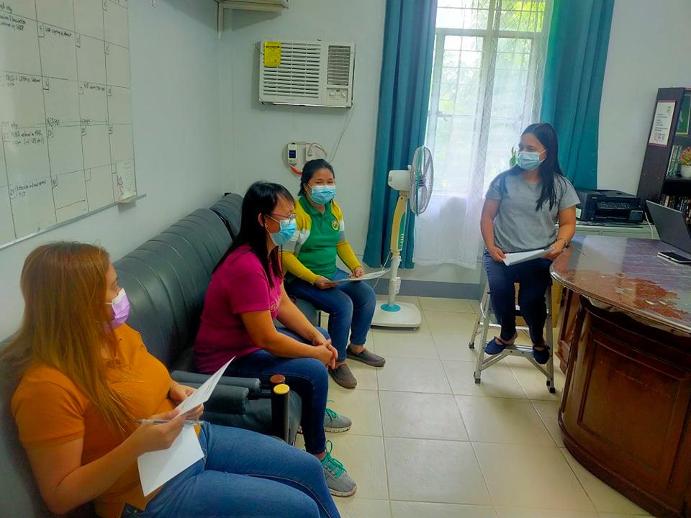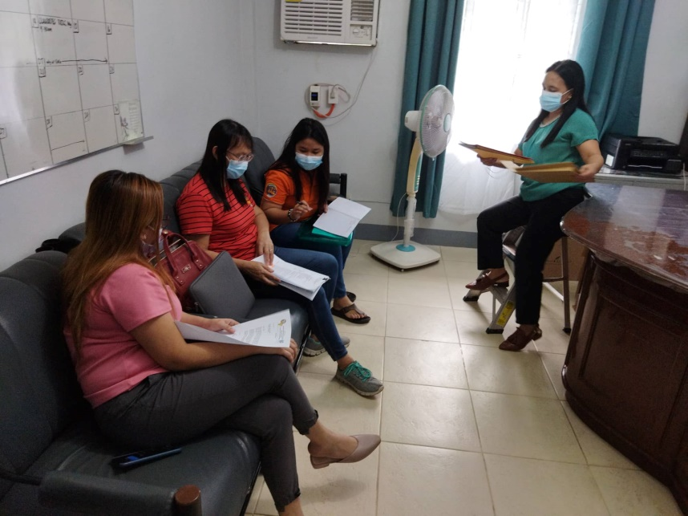

On October 28, 2021, a consultation meeting with Mr. Glenn Ortiz, Municipal Agriculturist of San Miguel, Bulacan, was held to discuss project collaboration.

Some program members in fornt of San Ildefonso Municipal Hall after the meeting with the staff of the LGU-MAO.

Meeting with Mr. Victotio Joson, Jr and veterinarian of San Ildefonso- Municipal Agriculutre Office on Oct. 28.

Program meeting on visit to LGUs of San Ildefonso and San Miguel last October 25, 2021.

Program meeting on planning of schedule of visit to LGUs last October 12, 2021.

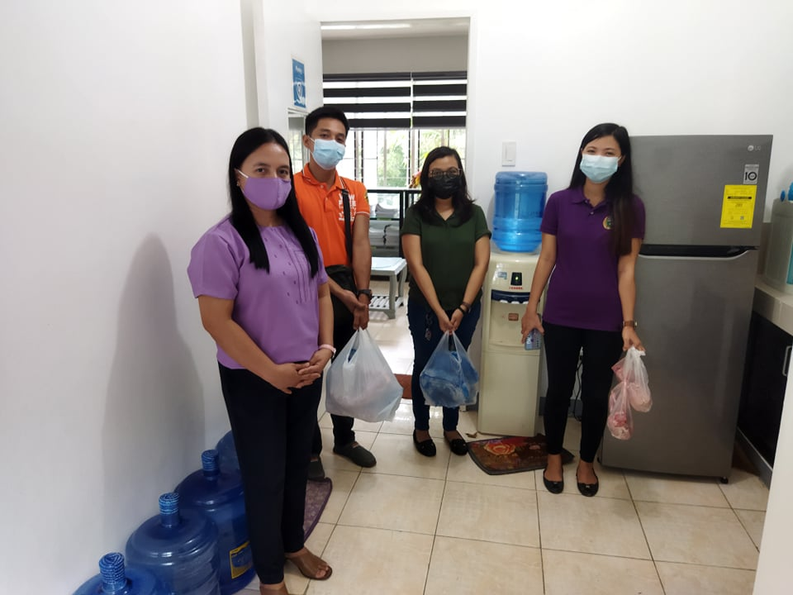

RaPDS Project Staff of Lapanuggets product study received the rabbit meat from the BASC rabbit project on Oct 20.

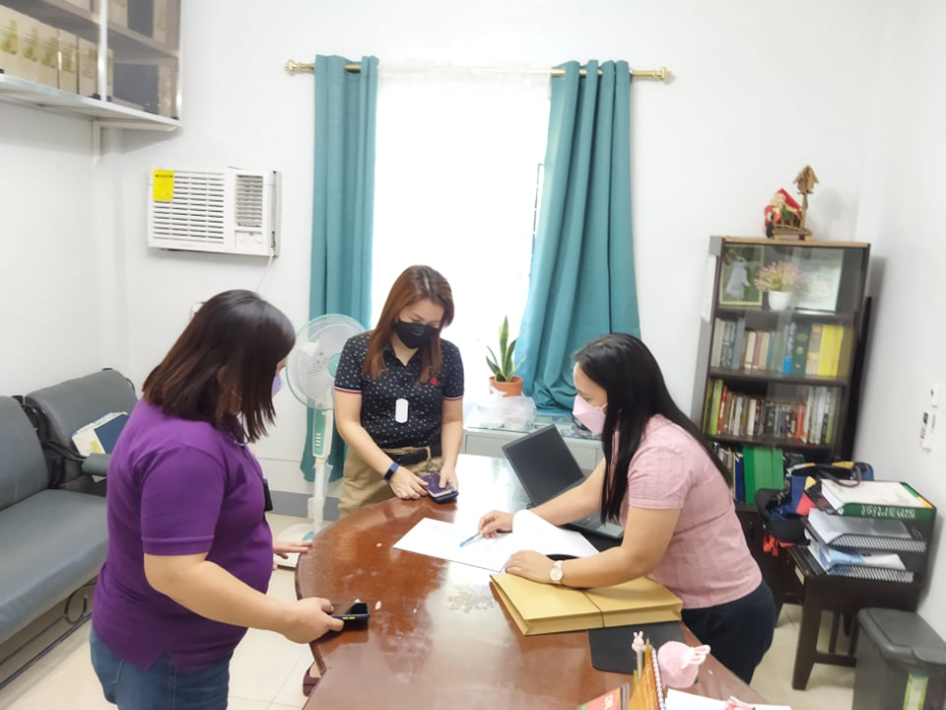

Meeting of the 4K Program Leader with two study leaders under the Rabbit Product Dev’t & Standardization (RaPDS) Project on Oct. 27.

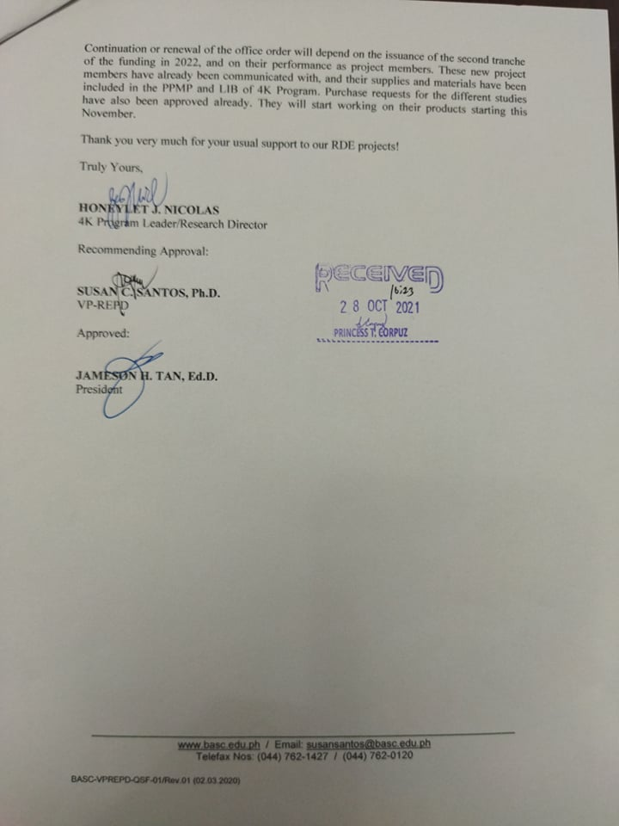

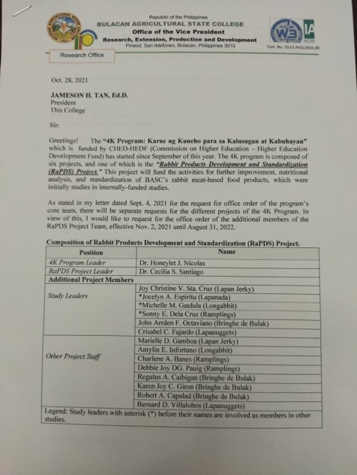

The approved Office Order of the additional members of Rabbit Product Dev’t & Standardization (RaPDS) Project under the 4K Program.